
Cosc 32133-lab2
PS/2020/010


Controller
StudentController.java
package com.example.lab2.Controller;
import com.example.lab2.Model.Student;
import com.example.lab2.Service.StudentService;
import org.springframework.beans.factory.annotation.Autowired;
import org.springframework.http.HttpStatus;
import org.springframework.http.ResponseEntity;
import org.springframework.web.bind.annotation.*;
import java.util.List;

@RestController
@RequestMapping("/api/students")
@CrossOrigin(origins = "*")
public class StudentController {

@Autowired
private StudentService studentService;
@PostMapping
public ResponseEntity<Student> saveEmployee(@RequestBody Student student){
return new ResponseEntity<Student>(studentService.saveStudent(student),HttpStatus.CREATED);
}
//GetAll Rest Api
@GetMapping
public List<Student> getAllStudents(){
return studentService.getAllStudents();
}
//Get by Id Rest Api
@GetMapping("{id}")
// localhost:8080/api/employees/1
public ResponseEntity<Student> getEmployeeById(@PathVariable("id") long
employeeID){
return new ResponseEntity<Student>(studentService.getStudentById(employeeID),HttpStatus.OK);
}
//Update Rest Api
@PutMapping("{id}")
public ResponseEntity<Student> updateEmployee(@PathVariable("id") long
id,
@RequestBody Student employee){
return new ResponseEntity<Student>(studentService.updateStudent(employee,id),HttpStatus.OK);
}
//Delete Rest Api
@DeleteMapping("{id}")
public ResponseEntity<String> deleteStudent(@PathVariable("id") long
id){
//delete employee from db
studentService.deleteStudent(id);
return new ResponseEntity<String>("Student deleted Successfully.",HttpStatus.OK);
}

}

Model
Student.java
package com.example.lab2.Model;

import jakarta.persistence.*;
import jakarta.persistence.Entity;
import jakarta.persistence.GeneratedValue;
import jakarta.persistence.GenerationType;
import jakarta.persistence.Id;
import jakarta.persistence.Table;
import lombok.AllArgsConstructor;
import lombok.Data;
import lombok.NoArgsConstructor;

@Entity
@AllArgsConstructor
@NoArgsConstructor
@Data
@Table(name="Student")
public class Student {
@Id
@GeneratedValue(strategy = GenerationType.IDENTITY)
private long id;
private String firstName;
private String lastName;
private String email;
private String department;
private String yearOfEnrollment;

public long getId() {
return id;
}

public void setId(long id) {
this.id = id;
}

// Getter and Setter for firstName
public String getFirstName() {
return firstName;
}

public void setFirstName(String firstName) {
this.firstName = firstName;
}

public String getLastName() {
return lastName;
}

public void setLastName(String lastName) {
this.lastName = lastName;
}

// Getter and Setter for email
public String getEmail() {
return email;
}

public void setEmail(String email) {
this.email = email;
}

// Getter and Setter for department
public String getDepartment() {
return department;
}

public void setDepartment(String department) {
this.department = department;
}

// Getter and Setter for yearOfEnrollment
public String getYearOfEnrollment() {
return yearOfEnrollment;
}

public void setYearOfEnrollment(String yearOfEnrollment) {
this.yearOfEnrollment = yearOfEnrollment;
}

}

Repository
StudentRepository.java
package com.example.lab2.Repository;
import org.springframework.data.jpa.repository.JpaRepository;

import com.example.lab2.Model.Student;

public interface StudentRepository extends JpaRepository<Student,Long> {

}

Service
Service.java
package com.example.lab2.Service.Impl;
import com.example.lab2.Model.Student;
import com.example.lab2.Repository.StudentRepository;
import com.example.lab2.Service.StudentService;

import java.util.List;
import java.util.Optional;

import org.springframework.beans.factory.annotation.Autowired;
import org.springframework.stereotype.Service;

@Service
public class StudentServiceImpl implements StudentService {
@Autowired
private StudentRepository studentRepository;

@Override
public Student saveStudent(Student student) {
return studentRepository.save(student);
}

@Override
public List<Student> getAllStudents() {
// TODO Auto-generated method stub
return studentRepository.findAll();
}

@Override
public Student getStudentById(long id) {
Optional<Student> employee = studentRepository.findById(id);
if(employee.isPresent()){
return employee.get();
}else {
throw new RuntimeException();
}
}

@Override
public Student updateStudent(Student student, long id) {
Student existingStudent =studentRepository.findById(id).orElseThrow(()-> new RuntimeException());
existingStudent.setFirstName(student.getFirstName());
existingStudent.setLastName(student.getLastName());
existingStudent.setEmail(student.getEmail());
existingStudent.setDepartment(student.getDepartment());
existingStudent.setYearOfEnrollment(student.getYearOfEnrollment());
// save
studentRepository.save(existingStudent);
return existingStudent;

}

@Override
public void deleteStudent(long id) {
studentRepository.findById(id).orElseThrow(()-> new
RuntimeException());
//delete
studentRepository.deleteById(id);}

}

Impl
StudentServiceImpl.java
package com.example.lab2.Service;
import java.util.List;

import com.example.lab2.Model.Student;

public interface StudentService {
Student saveStudent(Student student);
List<Student> getAllStudents();
Student getStudentById(long id);
Student updateStudent(Student student,long id);
void deleteStudent(long id);
}

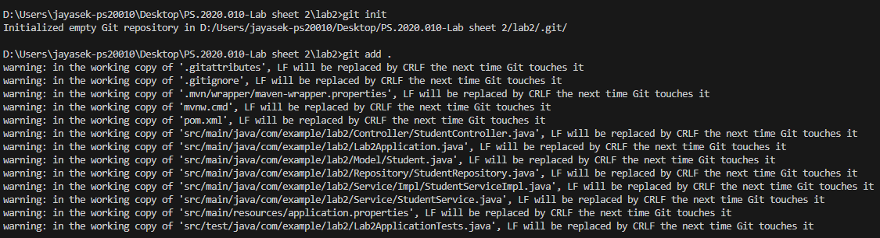
Git Operations

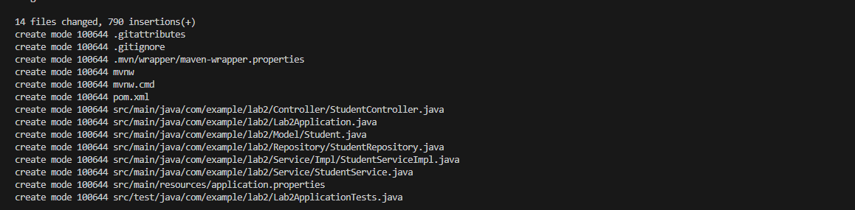
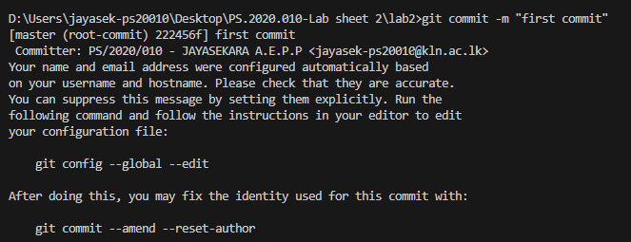

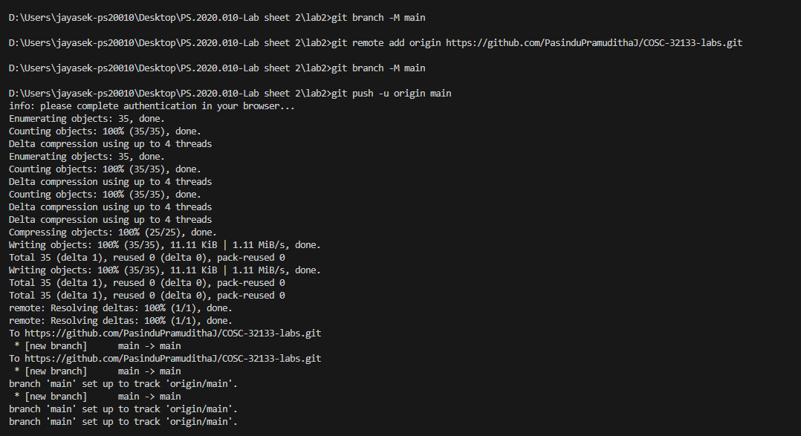
Outputs-:
